**

**DEPARTMENT OF SOFTWARE ENGINEERING**

# Web Development

|  |  |
| --- | --- |
| **Name** | **Khadija Hasnain** |
| **Class** | **BSSE 31 (V-A)** |
| **Submitted to** | **Dr Marriam Daud** |
| **I.D** | **SP21311** |
| **Web** | **Assignment 1** |

**Home:**



**About:**

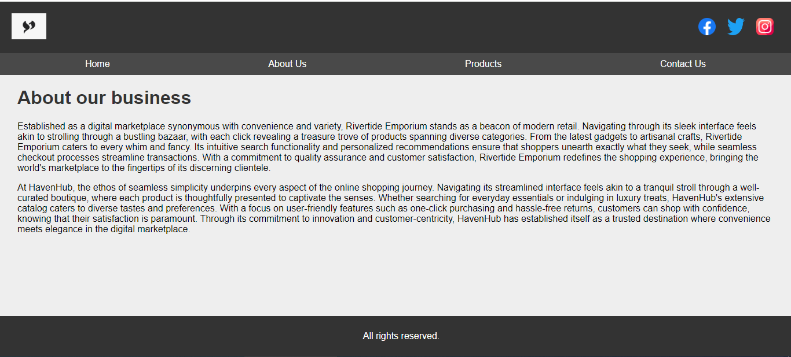

**Contact:**

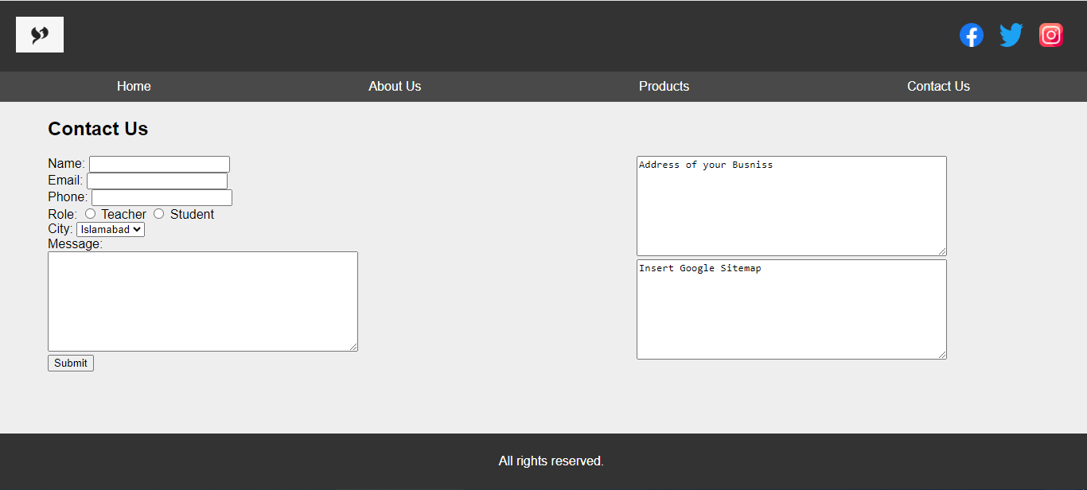

**Product:**

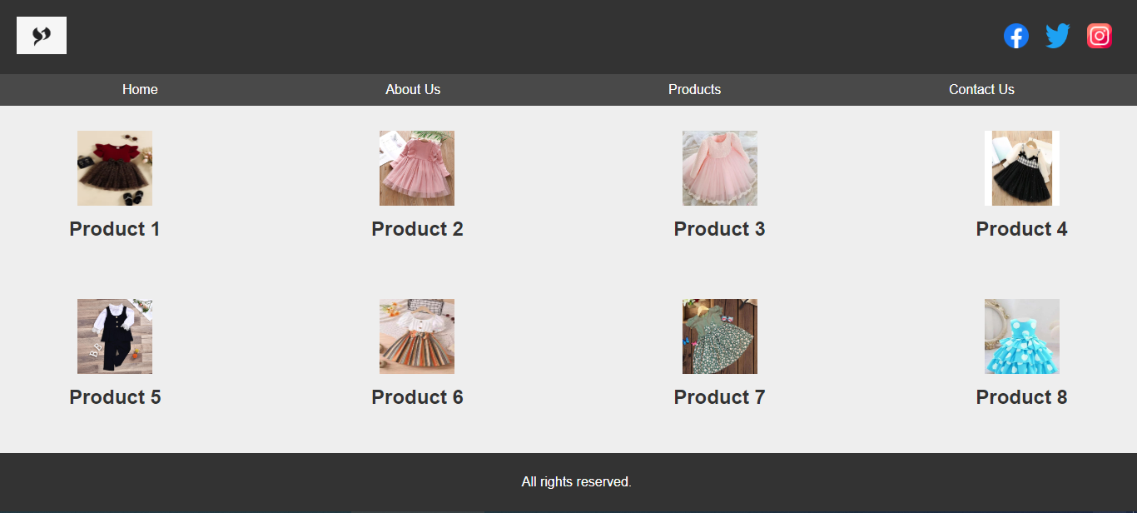

**Product detail:**

